Poster Introduction

Improving the use of alternative energies is one of Egypt’s main grand challenges. For instance, most of Egypt’s energy comes from fossil fuels, consisting of oil and gas. As illustrated in Figure 1. As a result, CO₂ emissions are around 217.806 megatons reaching 0.6% of the global emissions according to IEA.
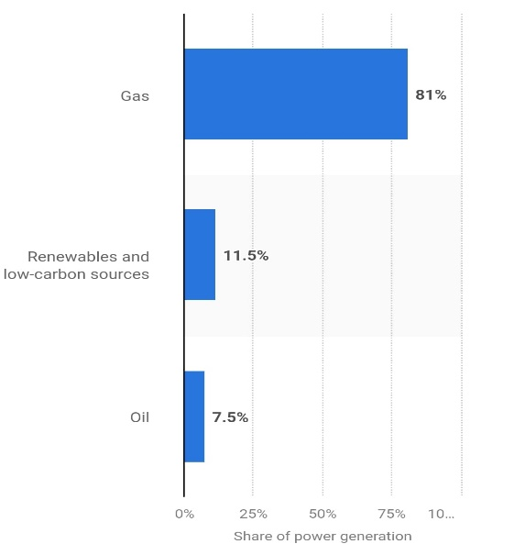
This causes an increase in temperature, climate change and pollution to the air, soil and water which brings us to the next grand challenge “Work to eradicate public health issues”. Which causes disease outbreaks and health concerns. As a result, “Reducing Power Shortage Through Alternative Energy” was concluded to be the problem to be solved.
After research, a multitude of solutions already tried were studied, two of which were Dogger Bank Windfarm and Benban Solar Park. Dogger Bank is a facility built to generate electricity from the wind in the United Kingdom, one of its strengths is reduced maintaince cost and mechanical wear as it uses a direct drive gearless system that provides lower energy loss. While one of its weaknesses is its large size which causes logisitical challenges, for example, the turbine’s blades are 107 meters long. As for Benban Solar Park, One of its strength points is reducing air pollution as it cuts CO₂ emissions by 2 million tons annually. However, it has a land use challenge because the 37 km² solar park occupies vast land.
Figure 1
The design requirements state that the prototype must generate at least 40 joules after 5 minutes, not exceed 0.5 m³ and that electricity is stored in any device. The prior solutions combined with research lead us to choose a vertical elliptical wind turbine as the selected solution. Furthermore, the selected solution uses recyclable materials and is considered a green energy source. The prototype is 0.10 m³ in volume and generates 2 watts/ 5 minutes with a battery to store electricity which exceeds the design requirements.

